About Retail store
- This is one of the world’s most recognized brands and one of America’s leading retailers. Target makes itself a preferred shopping destination by offering outstanding value, inspiration, innovation and an exceptional guest experience that no other retailer can deliver.
- This business case has information of 100k orders from 2016 to 2018 made at Target in Brazil. Its features allows viewing an order from multiple dimensions: from order status, price, payment and freight performance to customer location, product attributes and finally reviews written by customers.

Data is available in 8 csv files:
- customers.csv
- geolocation.csv
- order_items.csv
- payments.csv
- reviews.csv
- orders.csv
- products.csv
- sellers.csv

Each feature or columns of different CSV files are described below:

The customers.csv contain following features:
- customer_id : Id of the consumer who made the purchase.
- customer_unique_id :Unique Id of the consumer.
- customer_zip_code_prefix : Zip Code of the location of the - consumer.
- customer_city : Name of the City from where order is made.
- customer_state :State Code from where order is made(Ex- sao paulo-SP).

The sellers.csv contains following features:
- seller_id : Unique Id of the seller registered
- seller_zip_code_prefix : Zip Code of the location of the seller.
- seller_city : Name of the City of the seller.
- seller_state : State Code (Ex- sao paulo-SP)

The order_items.csv contain following features:
- order_id: A unique id of order made by the consumers.
- order_item_id: A Unique id given to each item ordered in the order.
- product_id: A unique id given to each product available on the site.
- seller_id: Unique Id of the seller registered in Target.
- shipping_limit_date: The date before which shipping of the ordered product must be completed.
- price: Actual price of the products ordered .
- freight_value: Price rate at which a product is delivered from one point to another.

The geolocations.csv contain following features:
- geolocation_zip_code_prefix: first 5 digits of zip code
- geolocation_lat: latitude
- geolocation_lng: longitude
- geolocation_city: city name
- geolocation_state: state

The payments.csv contain following features:
- order_id: A unique id of order made by the consumers.
- payment_sequential: sequences of the payments made in case of EMI.
- payment_type: mode of payment used.(Ex-Credit Card)
- payment_installments: number of installments in case of EMI purchase.
- payment_value: Total amount paid for the purchase order.

The orders.csv contain following features:
- order_id: A unique id of order made by the consumers.
- customer_id :Id of the consumer who made the purchase.
- order_status: status of the order made i.e delivered, shipped etc.
- order_purchase_timestamp: Timestamp of the purchase.
- order_delivered_carrier_date :delivery date at which carrier made the delivery.
- order_delivered_customer_date: date at which customer got the product.
- order_estimated_delivery_date: estimated delivery date of the products.

The reviews.csv contain following features:
- review_id: Id of the review given on the product ordered by the order id.
- order_id: A unique id of order made by the consumers.
- review_score :review score given by the customer for each order on the scale of 1–5.
- review_comment_title: Title of the review
- review_comment_message: Review comments posted by the consumer for each order.
- review_creation_date :Timestamp of the review when it is created.
- review_answer_timestamp: Timestamp of the review answered.

The products.csv contain following features:
- product_id: A unique identifier for the proposed project.
- product_category_name: Name of the product category
- product_name_lenght: length of the string which specifies the name given to the products ordered.
- product_description_lenght: length of the description written for each product ordered on the site.
- product_photos_qty :Number of photos of each product ordered available on the shopping portal.
- product_weight_g :Weight of the products ordered in grams.
- product_length_cm: Length of the products ordered in centimeters.
- product_height_cm: Height of the products ordered in centimeters.
- product_width_cm: width of the product ordered in centimeters.
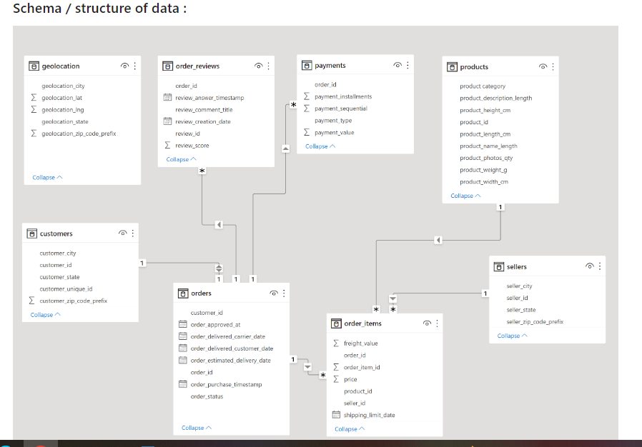

1. Usual exploratory analysis steps like checking the structure & characteristics of the dataset
- Data type of columns in a table
- Time period for which the data is given
- Cities and States of customers ordered during the given period

SELECT
COUNT(DISTINCT(seller_state)) Unique_states,COUNT(DISTINCT(seller_city)) Unique_cities
FROM
`1geo.sellers`;

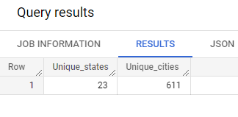
Insights-
Sellers are from 611 cities and 23 states in Brazil.

Unique products available in Target :

SELECT
COUNT((product_id)) as counts
FROM
`1geo.products`

Insights-
In products Data ,
total 32951 different products available in Target

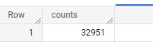

select distinct customer_city from `1geo.customers`;

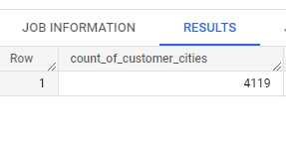
select distinct customer_state from `1geo.customers`;

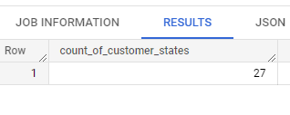
Insights-
There are customers available from 27 states and 4119 cities

select distinct customer_id from `1geo.customers`

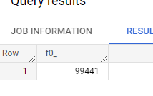

We have 99,441 customers of data available.

Time period for which the data is given

select MIN(date(order_purchase_timestamp)) min_Order_purchase_date ,Max(date(order_purchase_timestamp)) max_order_purchase_date from `1geo.orders`;

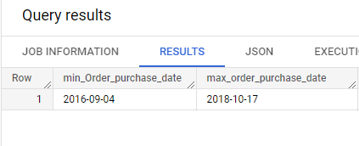

Insights-
#1.2Min Order purchase Date is 2016-september and max order purchase date is 2018 october
#1.2We have our data from September 2016 to October 2018

#Checking the differece between the order delievered and order recieved

select date_diff(max(date(order_delivered_customer_date)),min(date(order_estimated_delivery_date)),month) as diff from `1geo.orders`

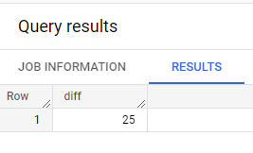

Insights

The dataset has total of 25 months of data

In-depth Exploration:
Is there a growing trend on e-commerce in Brazil? How can we describe a complete scenario? Can we see some seasonality with peaks at specific months?
What time do Brazilian customers tend to buy (Dawn, Morning, Afternoon or Night)?

select A.Year_2017,B.Year_2018,A.month from( select count(x.order_id) as Year_2017,extract(month from x.order_purchase_timestamp) month from
(
select o.order_purchase_timestamp,o.order_id from `1geo.orders` o where extract(year from o.order_purchase_timestamp)=2017
) x group by month order by month) A join
(
select count(x.order_id) as Year_2018,extract(month from x.order_purchase_timestamp) month from
(
select o.order_purchase_timestamp,o.order_id from `1geo.orders` o where extract(year from o.order_purchase_timestamp)=2018
) x group by month order by month) B on A.month=B.month order by month
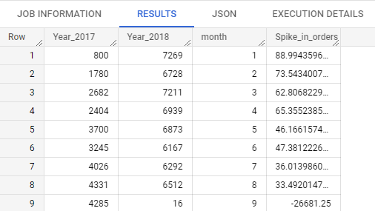

During year 2017 there is a sudden spike in Feb month in orders.
During Year 2018 in Jan month we had maximum orders and in 2017 we had minimum orders in Jan
There is a massive growth.
In January month there is 9x growth
There is a growing trend in e-commerce as data shows clearly there is increase in orders in year 2018 from 2017.
Ignoring the data for months after August as we have incomplete data for Year 2018

Checking average monthly orders to check spike is certain seasons :
SELECT
x.month,
AVG(x.num_of_orders) AS average_orders_per_month
from
(
SELECT
extract(year from order_purchase_timestamp) as year,
extract(month from order_purchase_timestamp) as month,
count(order_id) as num_of_orders
from
`1geo.orders`
group by
year,month
order by
year,month
) as x
group by x.month
order by x.month
;

Average number of orders are higher during November month.

September and October month average orders are comparatively low.

2.1Comparing the data Year and month wise :

select extract( month from o.order_purchase_timestamp) as Month,extract(Year from o.order_purchase_timestamp) as year,sum(oi.price) as Total_price from `1geo.orders` o join `1geo.order_items` oi on o.order_id=oi.order_id group by Month,year order by Month,year;

Month | year | Total_price
1 | 2017 | 120312.9
1 | 2018 | 950030.4
2 | 2017 | 247303
2 | 2018 | 844178.7
3 | 2017 | 374344.3
3 | 2018 | 983213.4
4 | 2017 | 359927.2
4 | 2018 | 996647.8
5 | 2017 | 506071.1
5 | 2018 | 996517.7
6 | 2017 | 433038.6
6 | 2018 | 865124.3
7 | 2017 | 498031.5
7 | 2018 | 895507.2
8 | 2017 | 573971.7
8 | 2018 | 854686.3
9 | 2016 | 267.36
9 | 2017 | 624401.7
9 | 2018 | 145
10 | 2016 | 49507.66
10 | 2017 | 664219.4
11 | 2017 | 1010271
12 | 2016 | 10.9
12 | 2017 | 743914.2

From the data its visible the sale for 2018 have increased a lot as we have data for only 8 Months for 2018 we can only compare data for 8 months as there is partial data available for 9th month of 2018 so eliminating analysis on the same.

From the year 2017 to 2018 The count of orders have increased as its visible by month on month trend

As compared to year 2016 we have data available for 9 to 12th months which is less compared to following years.

Checking growth in orders percentage(2017 vs 2018)

select sum(Y.Year_2017) Orders_Sum_2017,sum(Y.Year_2018) Orders_Sum_2018 from (select A.Year_2017,B.Year_2018,A.month from( select count(x.order_id) as Year_2017,extract(month from x.order_purchase_timestamp) month from
(
select o.order_purchase_timestamp,o.order_id from `1geo.orders` o where extract(year from o.order_purchase_timestamp)=2017

) x group by month order by month) A join
(
select count(x.order_id) as Year_2018,extract(month from x.order_purchase_timestamp) month from
(
select o.order_purchase_timestamp,o.order_id from `1geo.orders` o where extract(year from o.order_purchase_timestamp)=2018
) x group by month order by month) B on A.month=B.month order by month) as Y

54011-31884/85995=.25

There have been increase of orders by 25 percent in 2018.

Checking increase/decrease in revenue from 2017 to 2018

select *,total_revenue-lag(total_revenue) over (order by m_year) from

(select extract(year from o.order_purchase_timestamp) m_year,sum(m.total_amount) as total_revenue from `1geo.orders` as o join(
select (od.freight_value + od.price) total_amount,od.order_id from `1geo.order_items` as od ) m on o.order_id=m.order_id
group by m_year
) order by m_year

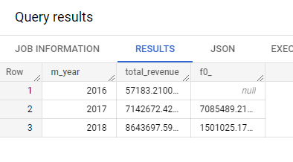
There have been 21 percent increase in revenue in 2018

select
FORMAT_TIMESTAMP("%a", order_purchase_timestamp) as day,
count(order_id) as number_or_orders
from `1geo.orders`
group by day
;

Monday,Tuesday, and Wednesdays have relatively higher number of orders.

Checking distribution of product categories:

SELECT product_category,count(distinct(ois.product_id)) as Number_of_products,count(distinct(ois.order_id)) as Number_of_orders,sum(price) as total_price FROM `1geo.order_items` as ois join `1geo.products`
as p on p.product_id = ois.product_id GROUP BY p.product_category ORDER BY total_price desc,Number_of_orders desc LIMIT 20;

Health and beauty, Watches present, bed table bath, sport leisure, computer accessories, Furniture Decoration, housewares,Automotive are some of the top selling product categories.

PCs and Musical Instruments category have relatively less number of products , but contributes in a high revenue.

top 10 product category having the costliest items in it.
select
p.product_category,
max(ois.price) as max_price_product
from `1geo.orders` as o
join `1geo.order_items` as ois
on o.order_id = ois.order_id
join `1geo.products` as p
on ois.product_id = p.product_id
group by
p.product_category
order by
max_price_product desc
limit 10
;
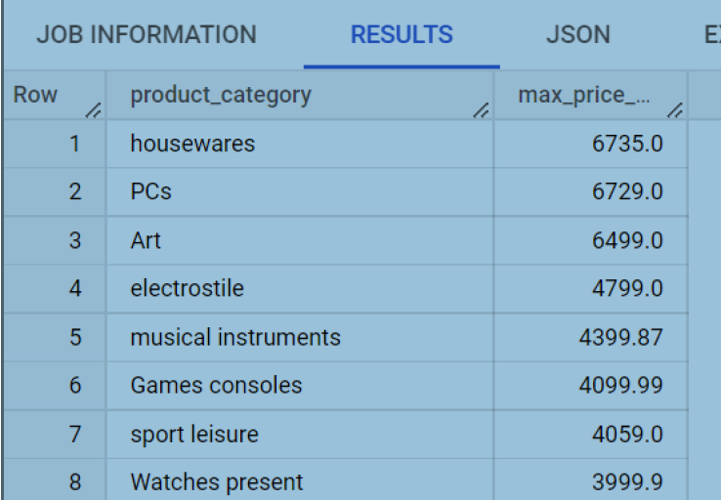

op 10 product category having the cheapest items in it.
select
p.product_category,
min(ois.price) as min_price_product
from `1geo.orders` as o
join `1geo.order_items` as ois
on o.order_id = ois.order_id
join `1geo.products` as p
on ois.product_id = p.product_id
group by
p.product_category
order by
min_price_product
limit 10
;

#Analyzing at what time brazilians place there orders

select x.timing,count(x.timing) as Counts
from(
select order_id,order_purchase_timestamp,case when extract(hour from order_purchase_timestamp) between 5 and 8 then 'Early Morning'
when extract(hour from order_purchase_timestamp) BETWEEN 8 and 11 then 'Morning'
when extract(hour from order_purchase_timestamp) between 12 and 17 then 'Afternoon'
when extract(hour from order_purchase_timestamp) between 18 and 21 then 'Evening'
when extract(hour from order_purchase_timestamp) between 22 and 23 then 'Night'
when extract(hour from order_purchase_timestamp) >= 24 then 'After midnight'
when extract(hour from order_purchase_timestamp) BETWEEN 0 AND 4 then 'After midnight'
else null
end as timing from `1geo.orders`) as x group by x.timing order by Counts;

Most orders done by brazilians are in between 12 to 17 thats during afternoon
#In Brazil people tend to order very less after midnight and early morning between 0 to 8.

Month On Month comparison for the number of orders.

select A.Year_2017,B.Year_2018,A.month from( select count(x.order_id) as Year_2017,extract(month from x.order_purchase_timestamp) month from
(
select o.order_purchase_timestamp,o.order_id from `1geo.orders` o where extract(year from o.order_purchase_timestamp)=2017
) x group by month order by month) A join
(
select count(x.order_id) as Year_2018,extract(month from x.order_purchase_timestamp) month from
(
select o.order_purchase_timestamp,o.order_id from `1geo.orders` o where extract(year from o.order_purchase_timestamp)=2018
) x group by month order by month) B on A.month=B.month order by month

Geographical analysis of how are customers distributed throughout Brazil country
Number of orders per state
select
c.customer_state,
count(o.order_id) as number_of_orders_per_state
from `1geo.orders` as o join `1geo.customers` as c
on o.customer_id= c.customer_id
group by
c.customer_state
order by number_of_orders_per_state desc

Checking distribution of product categories:

Checking distribution of product categories
SELECT product_category,count(distinct(ois.product_id)) as Number_of_products,count(distinct(ois.order_id)) as Number_of_orders,sum(price) as total_price FROM `1geo.order_items` as ois join `1geo.products`
as p on p.product_id = ois.product_id GROUP BY p.product_category ORDER BY total_price desc,Number_of_orders desc LIMIT 20;

top 10 product category having the costliest items in it.
select
p.product_category,
max(ois.price) as max_price_product
from `1geo.orders` as o
join `1geo.order_items` as ois
on o.order_id = ois.order_id
join `1geo.products` as p
on ois.product_id = p.product_id
group by
p.product_category
order by
max_price_product desc
limit 10
;

Health and beauty, Watches present, bed table bath, sport leisure, computer accessories, Furniture Decoration, housewares,Automotive are some of the top selling product categories.
#PCs and Musical Instruments category have relatively less number of products , but contributes in a high revenue.
